**ASSIGNMENT # 01**



**Spring 2023**

**Computer Programming Theory**

Submitted by: **JAMAL KHAN**

Registration No. : **22PWCSE2203**

Class Section: **B**

“On my honor, as student of University of Engineering and Technology, I have neither given nor received unauthorized assistance on this academic work.”

Student Signature: ______________

Submitted to:

**Dr. M Athar Sethi**

May 30, 2023

Department of Computer Systems Engineering

University of Engineering and Technology, Peshawar

**Implementation Of 8x1 Multiplexer Using If Else Structure**

* ***Source code:***

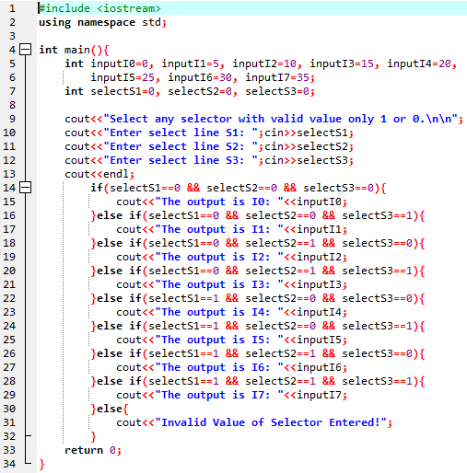

* ***Output*:**

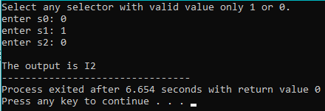

**Implementation Of 8x1 Multiplexer Using Conditional Structure**

* ***Source code:***

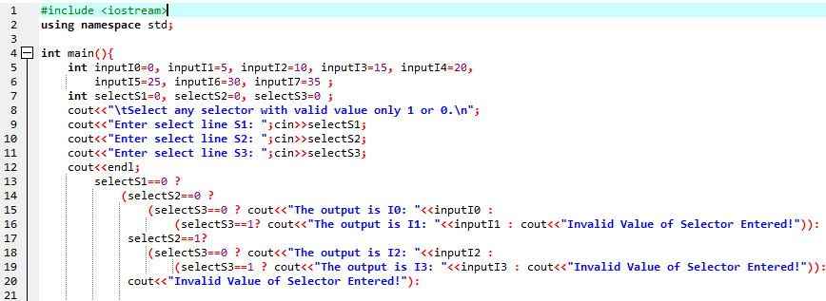

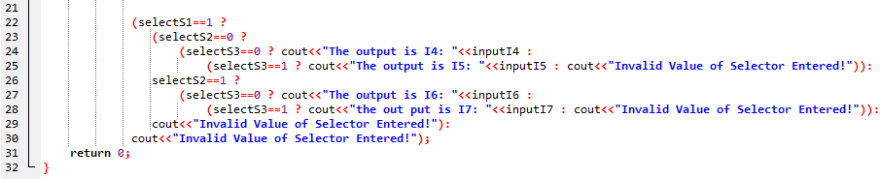

* ***Output*:**

